COIT13229: Applied Distributed Systems

016

Assignment 1: Java Client/Server Application

(Individual submission)

Submitted by Ajay Dangol (12046287)

Campus: Sydney Campus

Lecturer/Tutor: Partha Gangavalli

# Report on Assessment 1

First locate the file Assessment1.zip and unzip it. You will see several files, 7 files altogether i.e. Member.txt, Member.java, TCPClient.java, TCPServer.java, UDPClient.java and UDPServer.java.

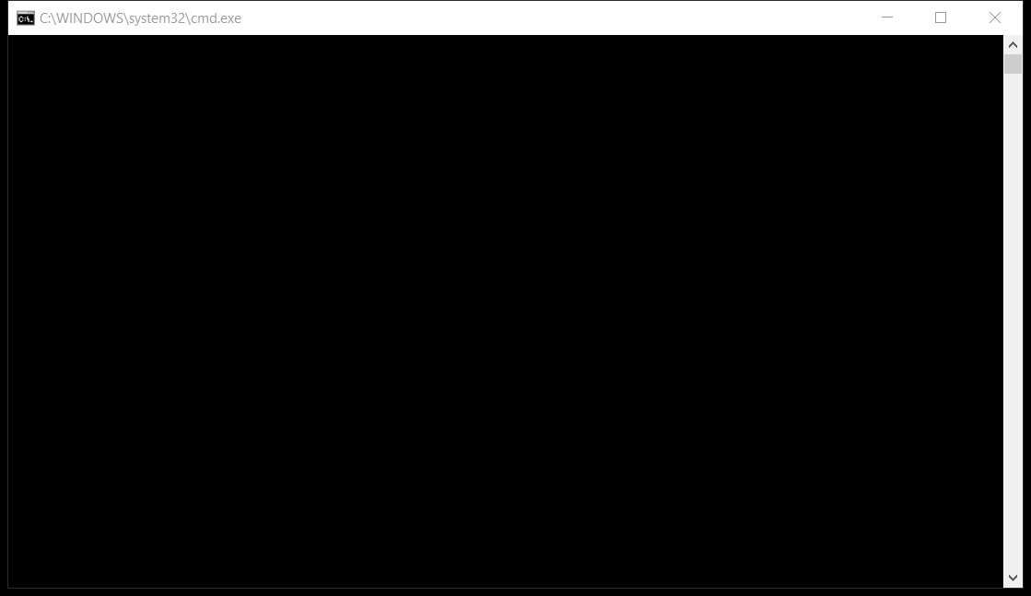Then first open the file TCPServer.java and then compile going to tools menu then external tools or you can use the shortcut key “Ctrl+1” and then run the file using the shortcut key “Ctrl+2”. You will see a black window.

After this open the file TCPClient.java and then compile and the run the code. You will then be asked to enter the details of the member. The you can see the message “Receiving data from the client” on the TCP Server’s black window.

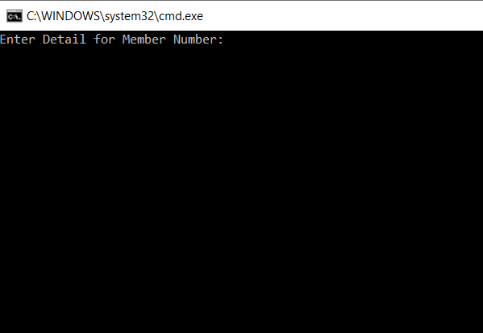

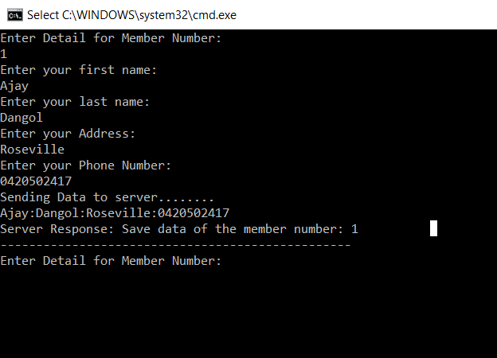

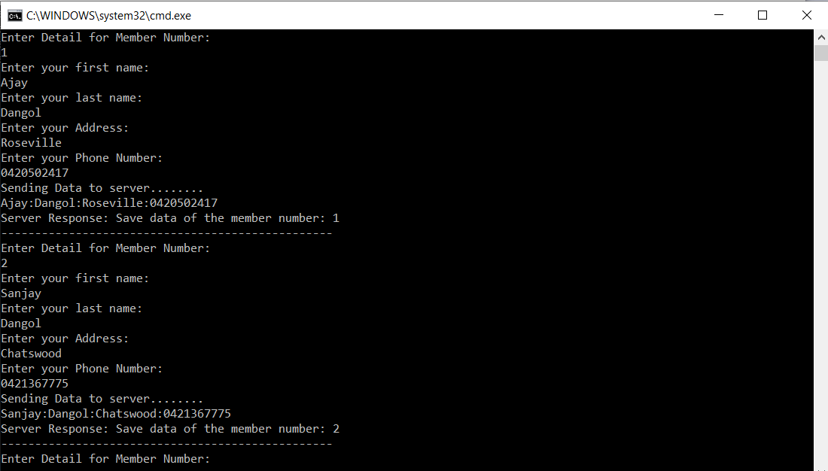

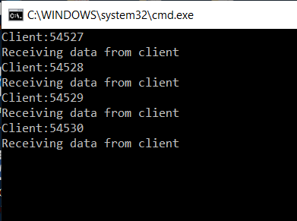

You can enter the details of multiple clients as TCP Server can accept connection from more than one TCP Client. Here I have entered details of 4 members.

After this, TCP Server creates a file named “member.txt” and “memberlistObject” and writes the data to the file “member.txt” then the TCP Server converts text to object in every two seconds and writes it to object file “memberlistObject”.

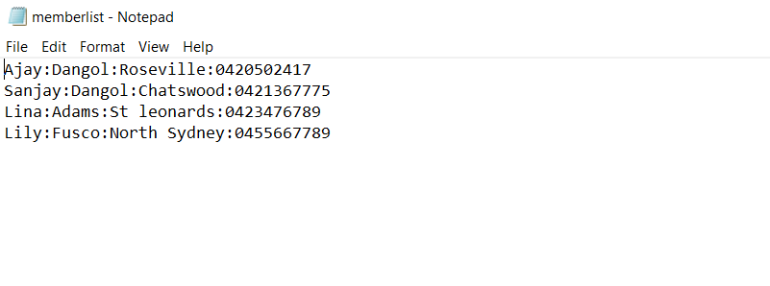



Similarly, open the file named UDPServer.java followed by compile and run. Likewise, open the file UDPClient.java and then compile and run it.

